Projectors and Dvd Player

Introduction
This document describes how to set up the projector and Dvd player.
The same projector is used to show computerized slide show and to display DvD movies.

Projector to show computerized slide show
There is a Viewsonic projector. It is stored in the Social room closet – it is always on top of the cart with wheels. Usually, both the projector and Dvd player are on the top of the cart.

Steps to use Projector

1. Position cart with projector
Plug in the projector – there will be a long extension chord available in the social room to plug this in

2. Turn on the projector by pressing the ‘Power’ button once

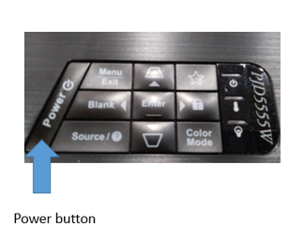

3. Make picture level
Sometimes the picture does not look level on the screen. There is a small piece of paper under the left side of projector used to make picture more level.

4. Adjust the size and focus of the power point slides
The lens of the projector has 2 controls. One changes the focus and one changes the sizing.
Move the sizing control to adjust the size of the picture as large as you want. If it is still not large enough, then move the projector further away from the front screen.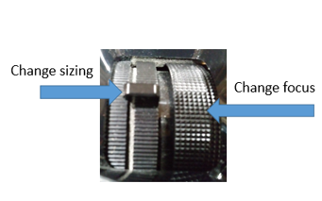

5. Connect one end of HDMI cable to the projector. Both ends of the cable are identical (see picture below)
This step is only needed if you are displaying viewgraphs for a lecture.

6. Connect the other end of this same HDMI cable to the laptop.
This step is only needed if you are displaying viewgraphs for a lecture.
1. Display the power point slide on the laptop.
2. Connect the other end of HDMI cable to the laptop while power point slide is being displayed. Look at the screen at front of room. If the screen shows text in lower right that says ‘no signal’ then try unplugging the HDMI cable and plugging it back in again. You can do this for both the computer and the projector.

Note: Microsoft laptops sometimes have problems with this; Apple laptops generally do not.

7. Turn Off projector
When done using the projector, turn it off.
Press the ‘power’ button once and wait a second – you will see a dialog pop up on the front screen. Not push the ‘power’ button a second time and the projector will turn off.

Showing DvD movies

1. Position Cart
On top of the cart is the projector and DvD player. The second shelf has the power and volume control for DvD player. The bottom shelf has the speaker.

2. Projector set up – already described in previous section
Turn on projector and deal with sizing and focus controls

3. Connect wires 3 wires (red, white & yellow)
Most of the time these wires will already be connected but just in case they are not, you should know how to connect them.
There are 3 wires (red, white & yellow).
On the DvD player, there are 3 holes colored red, white & yellow
On the Projector, there is just one yellow hole
So, connect DvD to projector with yellow wire by plugging both ends into the yellow holes (see picture below)
Connect the Dvd to the speaker with red and white wires. Just match red to red and white to white (see picture below)

4. Turn on Dvd player & speaker - adjust volume
Turn on Dvd Player (see picture below)
Turn on Speaker (see picture below)
Adjust volume until 3 stripes appear (see picture below)

5. Insert DvD disc
Press the OPEN button on the front of the DvD player.
DvD disc holder will open up so you can insert the DvD disc.
Gently push on DvD disc holder and it will close

6. Use Remote to control for the Dvd player
First press red button on remote to turn it on.
Use the buttons below on the remote. You need to point remote at DvD player to use the buttons – don’t point them at the screen.

Play / Pause button – cause DvD to play or pause

Fast forward and backward – labeled as ‘skip’

Stop button – stops the movie

‘Setup’ button – used to turn on English subtitles. All movies that we show have subtitles

