Microphones

Lectern Microphone
This microphone has a speaker built into the platform. The sound quality is very good. The speaker is built into the Lectern.
Sound quality is very good but some guest speakers don’t want to have to stand in front of lectern while talking – they want to be able to walk around.
To use this microphone:
1. Turn on the power switch. The power switch is on a black metal box (amplifier) that is on a shelf in the lectern. There is only one switch.
2. The microphone itself may or may not have a power switch. If it does, then turn it on.
3. Test microphone.

Lapel and hand-held microphone system

Steps to use lapel microphone
1. Turn on speaker. (on/off button is on the back). Also position speaker so it is facing the audience.
2. Turn on the device labeled ‘receiver’. You need to open up the device to see the ON/OFF button. To open the device, press together buttons on each side & cover will flip open. You need to hold the on/off button down for a second before it goes on. When you turn on device, you will see a bar graph display that tells you how charged up the batteries are. If you see 3 squares in the bar graph it is fully charged. If you see only 1 square – then replace the batteries
3. Connect the speaker to the ‘Receiver device’ – the device you just turned on.
4. Turn on the device labeled ‘microphone’. See step 2 above – it is exactly the same as turning on the ‘receiver’ device.
5. Connect the lapel microphone to the device labeled “Microphone” and clip the microphone onto the shirt of the speaker. Try to get the microphone as close to the speaker’s mouth as possible; otherwise, volume will be too low
6. Make sure that the ‘mute’ button is off on the microphone device. (see picture)
7. Adjust the volume. Start by turning 2 volume knobs as far counter clockwise as possible. Then turn 2 knobs clockwise until they are as loud as possible while still not giving any feedback while you are speaking into the microphone.
8. Test the microphone. If no sound, make sure all devices are on and plugged in correctly. Check that the ‘mute’ button is off.

Some caveats:
If the speaker has an extremely soft voice, they may have to use the hand-held microphone. The lapel microphone is limited on how loud you can make it before you get feedback. Also, speaker cannot put their mouth right up to the lapel microphone.

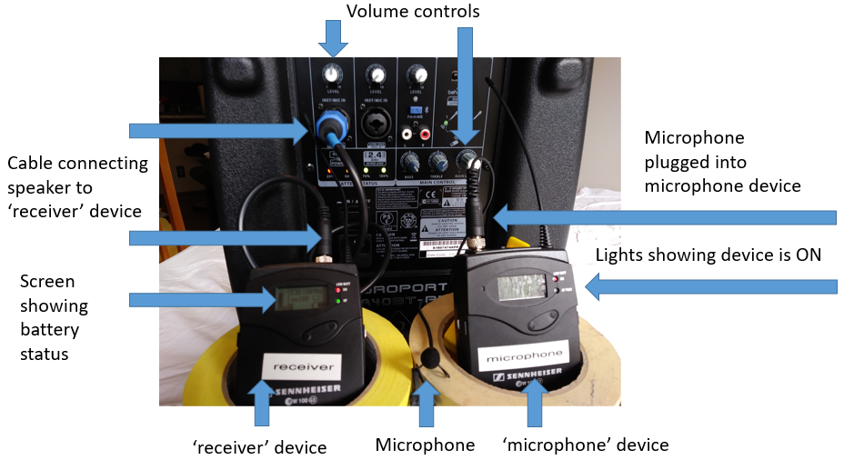

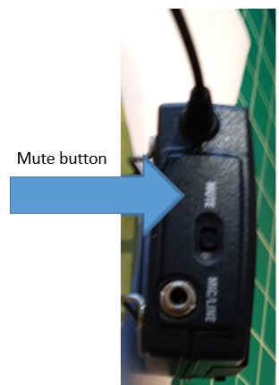

Steps to use hand-held microphone
This microphone has a long chord. It can be used for allowing the audience to ask questions.
1. Turn on speaker. (on/off button is on the back)
2. Connect hand-held microphone to the back of the speaker.
3. Adjust the volume. Start by turning 2 volume knobs as far counter clockwise as possible. Then turn 2 knobs clockwise until they are as loud as possible while still not giving any feedback while you are speaking into the microphone.

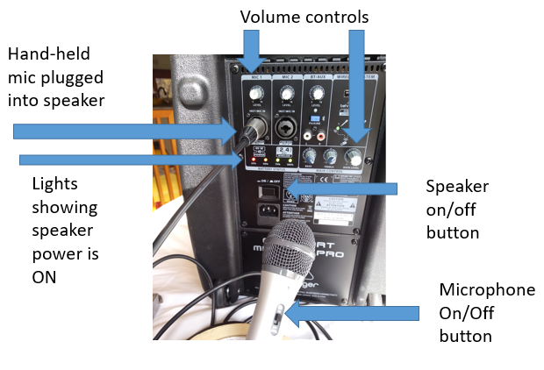

Microphone system that supports up to 4 microphones

This is a microphone system that supports up to 4 microphones.
Steps to use multi-microphone system:
1. Plug in power chord. Turn on the 2 different power switches. One switch is on the black metal box (amplifier) and the other is located in a hole on the back of the wooden platform (see picture below). Note: the power chord is actually a power strip that has an on/off button.
2. Plug in microphone(s) on left side while looking at front of wooden platform (see picture below)
3. Adjust volume on the black metal box (amplifier). Note there are 2 knobs – find the one labeled ‘volume’.

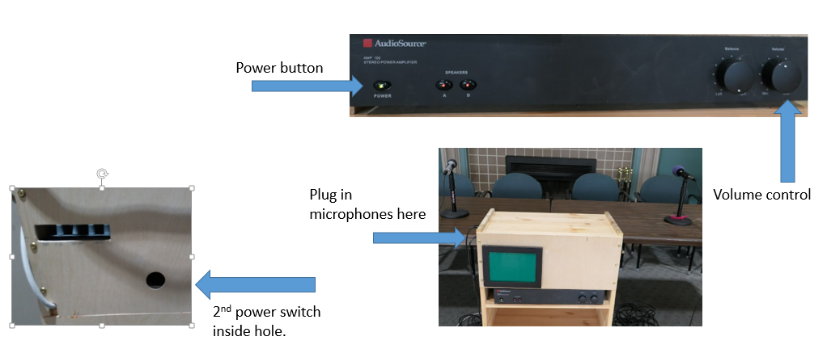
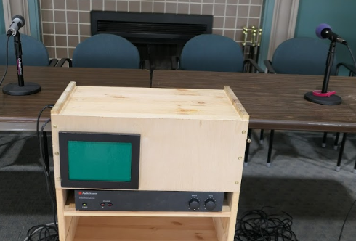

Putting equipment away
All of the AV equipment is stored in the South-most closet at the back of the Social room. The lapel microphone is stored on a shelf that is behind the cart with wheels that projector sit on.
Volunteers will need to have a new R key (opens exercise room & wood shop) made – this now will also open the AV equipment closet.
When you are done using the equipment, make sure to shut it off; otherwise the batteries will run down. Devices to shut off:
1. ‘microphone’ device - to turn OFF, hold on/off button until you see the words ‘OFF’ on the screen.
2. ‘receiver’ device - to turn OFF, hold on/off button until you see the words ‘OFF’ on the screen.
3. ‘speaker’
4. hand-held microphone.

